Temple Ewell CEP School: growing courageous advocates for a greener future
Temple Ewell Church of England Primary School has been celebrating a remarkable period of environmental action, pupil leadership and community partnership, as children across the school continue to show what it means to be courageous advocates for the world around them.
At Temple Ewell CEP School, courageous advocacy is about more than learning what is right. It is about having the confidence to speak up, take action and make a difference. The school teaches children to become changemakers: people who notice what needs to improve, speak up for others and take practical action to care for the world around them.
Over recent years, this vision has grown into a wide range of environmental projects led by pupils, staff and community partners. From improving habitats for wildlife to tackling waste, planting trees, collecting e-waste and celebrating local biodiversity, the children have shown that small actions can lead to meaningful change.
The school’s sustainability journey has now received significant recognition. Temple Ewell CEP School has recently been awarded the Eco-Schools Green Flag Award with Distinction, as part of the Keep Britain Tidy Eco-Schools programme. This is a wonderful achievement and reflects the way sustainability has become embedded across the whole school.
The school has also been recognised through the Kent Green School Awards, the Wilder Kent Award, the Woodland Trust Gold Award and the E-Waste Warriors Project. Together, these awards celebrate the school’s ongoing commitment to caring for creation and helping children understand their role as responsible citizens.
At the heart of the work are the pupils themselves. The School Council, Spiritual Team, Eco-leaders, Tree Guardians, Chough Champions and other pupil groups have all played an important part in shaping projects and inspiring others. Children have learned that advocacy is not only about raising money or awareness, but also about noticing what needs to change and doing something practical about it.
Taking action for nature
One of the school’s key priorities has been biodiversity. Children have helped to create and maintain habitats around the school grounds, including a bug hotel, hedgehog habitat, bird boxes, long-grass areas and other spaces designed to support insects, birds and small mammals.
The school’s birdwatching club has also grown from a very small group into a thriving regular club, showing how children’s curiosity about wildlife can develop into long-term care and commitment. Pupils have enjoyed spotting birds, learning how to identify them and understanding why local habitats matter.
Through the Tree Guardians project, children have worked with St Peter & St Paul’s Church and local community partners to explore, identify and celebrate trees in the churchyard. Pupils have learned about the importance of trees for biodiversity, climate, history and wellbeing, while also developing the confidence to share their knowledge with others.
Chough Champions and local conservation
Temple Ewell CEP School has also been involved in exciting wildlife advocacy through its Chough Champions work with Kent Wildlife Trust. Pupils have explored the story of the red-billed chough and its connection with Kent, learning about species recovery, conservation and the importance of protecting habitats.
This work has helped children understand that conservation is not something distant or abstract. It is connected to real places, real species and real decisions being made in their own county. Through filming, discussion, outdoor learning and pupil leadership, the children have become confident ambassadors for local wildlife.
The school’s whole-school Chough Champion Day was also recognised as a strong example of environmental action, showing how sustainability can bring pupils, staff and partners together around a shared purpose.
Community partnerships with real impact
Temple Ewell CEP School’s sustainability work has been strengthened by partnerships with local organisations, including St Peter & St Paul’s Church, the Parish Council, Kent Wildlife Trust, Artswork Dover, Kent County Council Sustainability Team and local environmental groups.
The school has worked on projects such as e-waste collection, local litter picking, wildlife education and creative environmental advocacy. During the E-Waste Warriors Project, the school community collected unwanted electrical items for recycling, helping families understand how everyday choices can reduce waste and protect the planet.
Children also took part in a community litter pick at Kearsney Abbey as part of the Great British Spring Clean, working alongside the Dover Environmental Crime Team. This helped pupils see that caring for the environment extends beyond the school gates and into the places used and loved by the wider community.
Sustainability across the curriculum
A key strength of Temple Ewell’s approach is that environmental learning is not limited to one club, one display or one special week. Sustainability is increasingly woven into curriculum learning, outdoor experiences, worship, pupil leadership and community projects.
Children have explored climate action, local freshwater ecosystems, the River Dour, farming practices, wildlife, trees, recycling, waste and biodiversity. Trips, Forest School opportunities and outdoor learning have helped pupils build meaningful connections with nature and understand their responsibility to care for the planet.
The school has also shared its work through newsletters and community updates, helping families and local people understand what pupils are doing and why it matters.
Courageous advocacy in action
As a Church of England school, Temple Ewell CEP School links its environmental work closely to its Christian vision and values. Children are encouraged to understand that caring for the world is part of caring for others, both now and in the future.
This same spirit can be seen in the school’s wider courageous advocacy and charity work. Pupils are encouraged to speak up for important causes and understand their role in the community and wider world. Recent examples include supporting Dover Food Bank, Dover Pantry, Children in Need, Comic Relief, Save the Children and other pupil-led charitable causes.
Together, these projects show that Temple Ewell pupils are learning to be thoughtful, active and compassionate citizens.
A greener future
The school’s sustainability journey is continuing to grow. Whether children are planting, recycling, observing wildlife, leading assemblies, creating displays, writing to decision-makers, collecting donations or speaking about environmental issues, they are learning that their voices matter.
Temple Ewell CEP School is proud to be helping children understand that they do not have to wait until they are adults to make a difference. They can begin now — in their classrooms, school grounds, churchyard, village and local community.
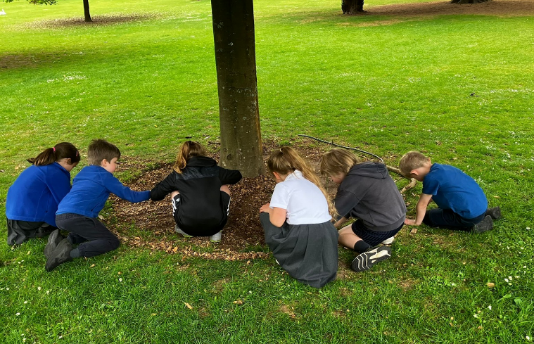
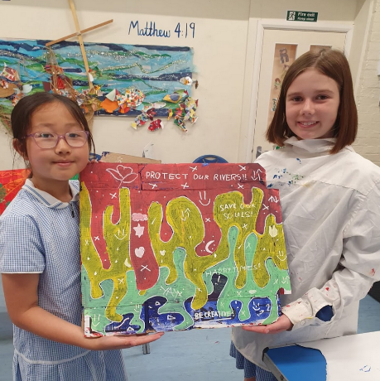
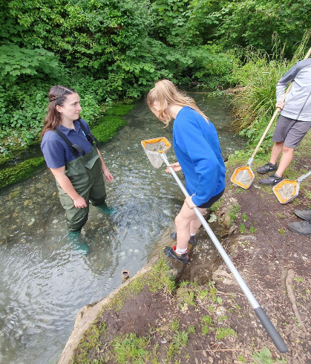
Through courage, compassion and action, Temple Ewell CEP School is helping pupils become the environmental leaders of the future.
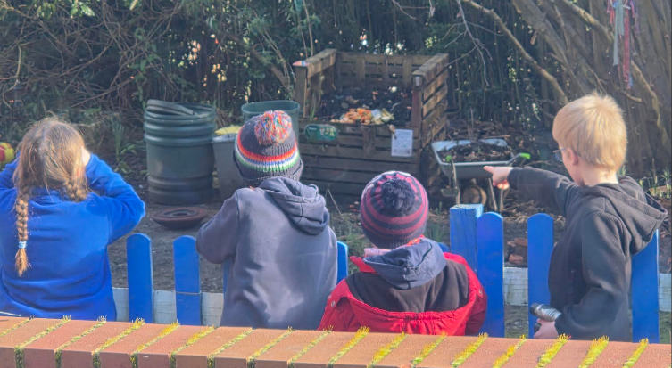
Top left:
Our self-led Birdwatching Club, run by pupils during lunchtimes and break times, encouraging children to notice, identify and care for local wildlife.
Top middle:
Pupils pond dipping with Martha Noakes, Freshwater Officer for White Cliffs Countryside Partnership, learning first-hand about freshwater habitats and the creatures that depend on them.
Top right:
Two pupils sharing their project work on protecting our rivers and oceans, helping to raise awareness of pollution and the importance of caring for water habitats.
Middle left:
Children investigating natural materials beneath the trees during outdoor learning at Kearsney Abbey, using the local environment as a classroom.
Lower left:
Charlie the Chough visiting Temple Ewell as part of our Chough Champions project with Kent Wildlife Trust, supporting pupils to learn about conservation and the return of this special species to Kent.
Bottom left:
Children placing a hedgehog “Travel Hodge” in our spiritual garden, creating a safe habitat and helping to improve biodiversity within the school grounds.
Bottom middle:
Acorns Class using their senses to explore nature, encouraging curiosity, connection and care for the natural world from an early age.

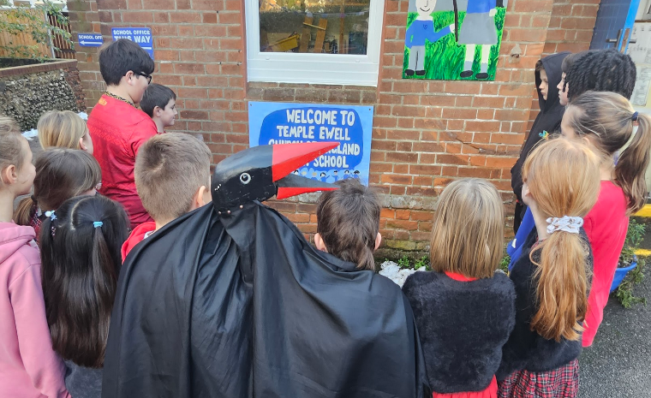

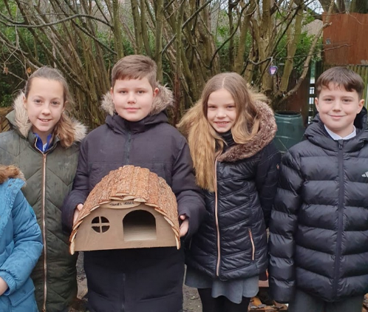
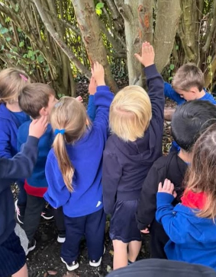

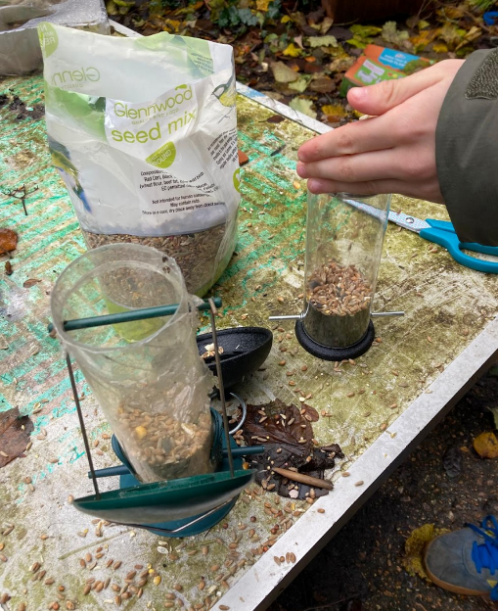
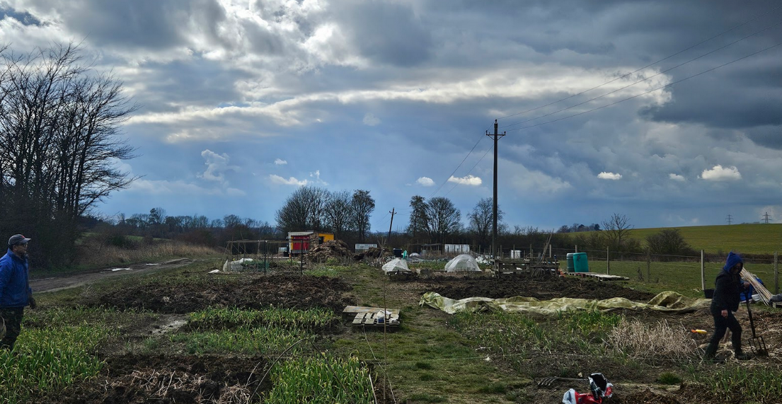

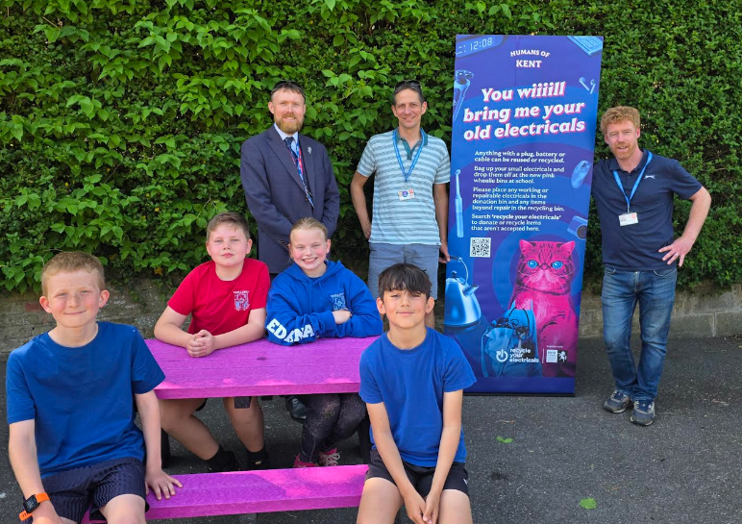
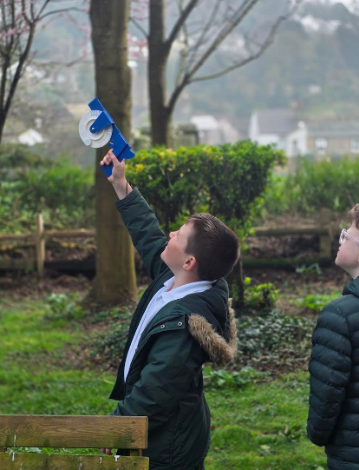

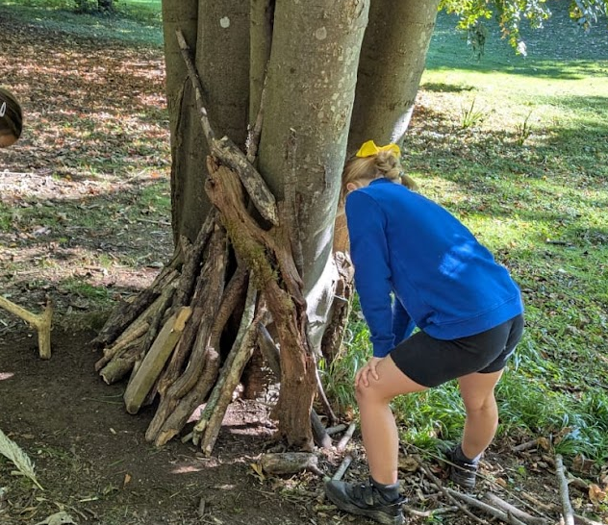
Top left:
Children from our nurture group, and other groups across the school, regularly fill and refill bird seed feeders around the school site to support local wildlife.
Top right:
Year 5 pupils visited Kent Farm in Posing as part of the Folkestone Nepalese Community project, learning about growing, community, food and caring for the land.
Middle left:
Pupils proudly sit on the recycled plastic junior picnic table awarded by Kent County Council’s Sustainability Team, after the school collected an average of 1.27kg of e-waste per pupil.
Middle right:
Pupils use a clinometer to help measure the height of trees, linking outdoor learning with maths, science and environmental understanding.
Lower left:
Children regularly take part in Forest School activities in our local woods, developing confidence, teamwork and a deeper connection with the natural world.

