Sustainability Success – e-Waste Warriors Project
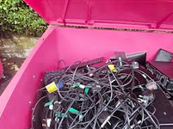
We are delighted to share some other fantastic news about our involvement in the e-Waste Warriors project, led by Kent County Council’s Sustainability Team.
What was the project about?
The initiative aimed to raise awareness of electrical waste and encourage communities to recycle, repair and reuse unwanted items rather than sending them to landfill. Schools across Kent were provided with specialist collection bins and resources to support learning around sustainability.
What did the children do?
Our pupils played an active role throughout the project. They:
- Collected unwanted electrical items from home to be safely recycled
- Took part in assemblies to learn about the environmental impact of e-waste
- Engaged in hands-on activities using Team Repair kits, exploring how items can be fixed and reused
- Developed a greater understanding of sustainability and their role in protecting the environment
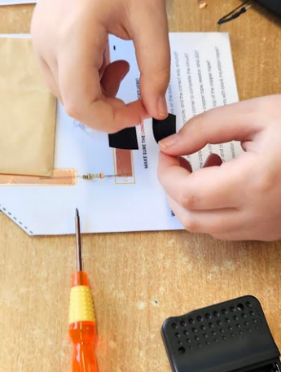
The enthusiasm and commitment shown by the children-and the support from our families-was exceptional.
What was the impact?
Thanks to this collective effort, Temple Ewell CEP School achieved an impressive 1.27kg of e-waste collected per pupil, making us one of the highest individual collectors across all participating schools in Kent.
Across the project as a whole:
- 36 schools took part
- Over 21,000 pupils were reached
- More than 5 tonnes of electrical waste were collected
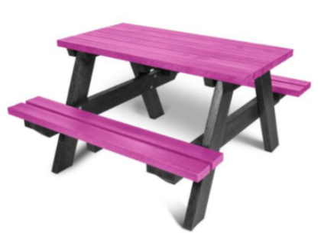
As a result of our success, we have been awarded a Holmfirth Recycled Plastic Junior Picnic Table for Schools, worth over £300. This high-quality, maintenance-free table-made entirely from recycled plastic-will be a fantastic addition to our school grounds and a lasting reminder of the positive difference our community has made.
A huge thank you to all of our families for your continued support. This has been a true whole-school effort and an excellent example of how we can work together to care for our environment.

