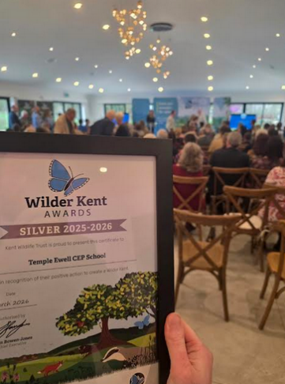
Wilder Kent Award - Silver Success!
We are delighted to share that Temple Ewell CEP School has achieved a Silver Award in the Wilder Kent Awards, led by the Kent Wildlife Trust.
This is the first time we have entered, making this achievement even more special. We are incredibly proud of what our pupils and wider school community have accomplished-and we are already setting our sights on Gold next year!
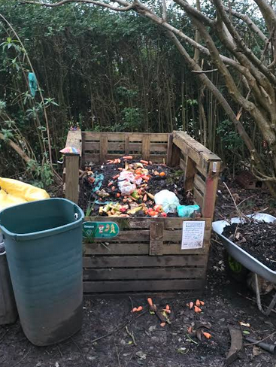
What did we achieve?
Our award submission recognised the wide range of environmental work taking place across the school, particularly the fantastic efforts of our Year 5 and 6 pupils.
This included:
- Work through the Global Action Project with Transform Our World
- Participation in Blue Influencers, in partnership with Kent Wildlife Trust
- Our current work towards becoming a Chough Champion School, tracking the progress of the red-billed chough
- Pupils creating a documentary project, exploring how choughs may have migrated along the Kent coastline

Learning Through Nature
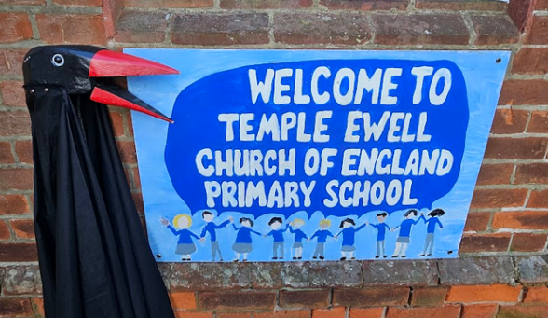
Our pupils are actively involved in protecting and learning about wildlife both in school and beyond:
- A pupil-led birdwatching club, growing from just 2 pupils to over 12 regular participants
- A thriving Nature Club, supporting our composting, planting and habitat care
- Installation of bird boxes and nesting homes across the school site
- Our “Hedgehog Travel Lodge”, providing a safe habitat for wildlife
- Bug hotels and wildlife areas supporting insects and biodiversity
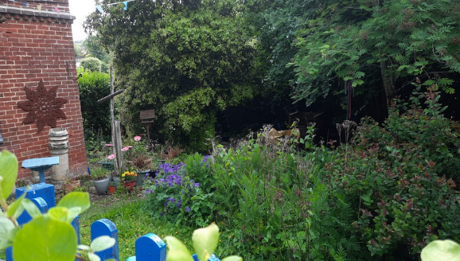
Caring for Our Environment
The award also recognised our ongoing commitment to sustainability:
- Use of water butts to collect and reuse rainwater
- Composting systems managed through Nature Club
- Litter picks within school and the local community
- Creative projects using recycled materials, including plastic artwork to raise awareness about reducing single-use plastics
Looking Ahead
This award reflects the passion, teamwork and responsibility shown by our pupils every day. They are not only learning about the environment-they are actively making a difference.
We are incredibly proud of their achievements and are excited to continue building on this success as we work towards Gold next year.

